**Mattekrysset**

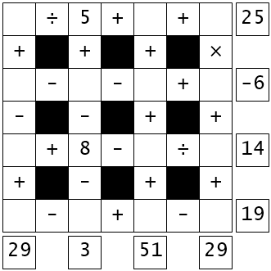

### Fill in the missing numbers

The missing values are the whole numbers between 1 and 16.

Each number is only used once.  
Each row is a math equation.  
Each column is a math equation.  
Remember that multiplication and division are performed before addition and subtraction.

**Sök min sambos och mitt för- och efternamn**

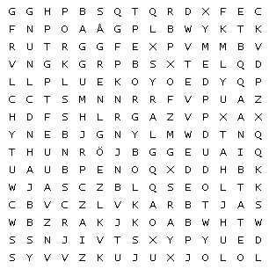

#### Find the word in the puzzle.

Words can go in any direction.  
Words can share letters as they cross over each other.